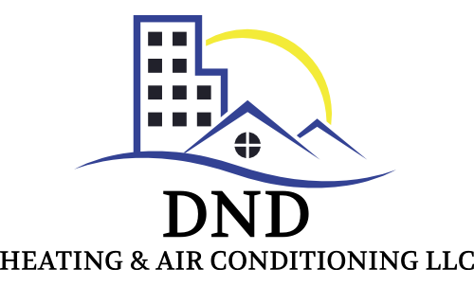
324 Crossfield Drive
Knoxville, TN 73920
(865)299-1452
DNDHVACR.COM
License:71904
MAINTENANCE AGREEMENT
Name:
Service Address: Billing Address:
City, State, Zip: City, State, Zip:
Phone:
Email:
Preferred Method of Contact (check one) Email Text Phone
Comments:

Regular preventative maintenance on your HVAC unit!
- Extends the life of your equipment!
- Helps reduce ever rising utility costs!
- Help avoid costly break downs!
- Ensures your equipment is operating safely and efficiently!

Additionally you will receive these added benefits!
- Priority Status
- No overtime charge
- 50% off each additional system in home
- 5% discount on unit replacement
- 10% discount on repairs
- 10% discount on diagnostic calls

DND Heating and Air Conditioning LLC will provide maintenance on all HVAC units at the above service address. We will notify you in a timely manner, via the method of your choice, prior to the service due date.
Spring Maintenance Includes | Fall Maintenance Includes
- Replace and/or clean all air filters | - Replace and/or clean all air filters
- Inspect and clean coils | - Inspect Coils
- Clean and inspect drain lines | - Clean and inspect drain lines
- Leak inspection and detection | - Inspect Heat Pump to ensure electric heaters are operating properly and efficiently
- Inspect, and lubricate all motors and compressors | - Evaluate refrigerant operating pressure
- Evaluate refrigerant operating pressure | - Inspect gas burners
- Inspect all electrical components | - Gas line leak inspection and detection
- Ensure proper and efficient equipment operation | - Inspect heat exchanger
 | - Ensure proper and efficient equipment operation
Guarantees and Additional Term:
- DND Heating and Air Conditioning LLC will guarantee our parts and labor for 30 days. Any manufacturer warranty for parts greater than 30 days will be honored.
- Any additional service work beyond the maintenance agreement is billed at the normal rate less 10%, with parts billed at the normal rate.
- The maintenance agreement will automatically renew on an annual basis, unless canceled by either party. No written notice is required.
- DND Heating and Air Conditioning LLC is not responsible for loss or damage due to service by another company or individual, theft, power loss, water, acts of God, or any other situation not in DND Heating and Air Conditioning LLC control.

Effective Date: | Model: | S/N: | Visit: Fall Spring | # of units:

I agree and acknowledge to the above maintenance agreement, that will be billed at $75.00 per system/per visit for the first system, and at $37.50 per additional system/per visit. I further understand and acknowledge that this agreement will renew on an annual basis, unless canceled by myself, or by DND Heating and Air Conditioning LLC.

DND Representative Customer Signature & Date

